1. Question: <https://leetcode.com/problems/valid-parentheses/submissions/1385119495/>

Solution: <https://leetcode.com/problems/valid-parentheses/post-solution/?submissionId=1385119495>



Time Complexity- O(n)

Space Complexity-O(n)

1. Question: <https://leetcode.com/problems/next-greater-element-i/description/>

Solution: <https://leetcode.com/problems/next-greater-element-i/post-solution/?submissionId=1385123086>



Time Complexity- O(n)

Space Complexity- O(n)

1. Question: <https://leetcode.com/problems/remove-all-adjacent-duplicates-in-string/description/>

Solution: <https://leetcode.com/problems/remove-all-adjacent-duplicates-in-string/post-solution/?submissionId=1385125850>

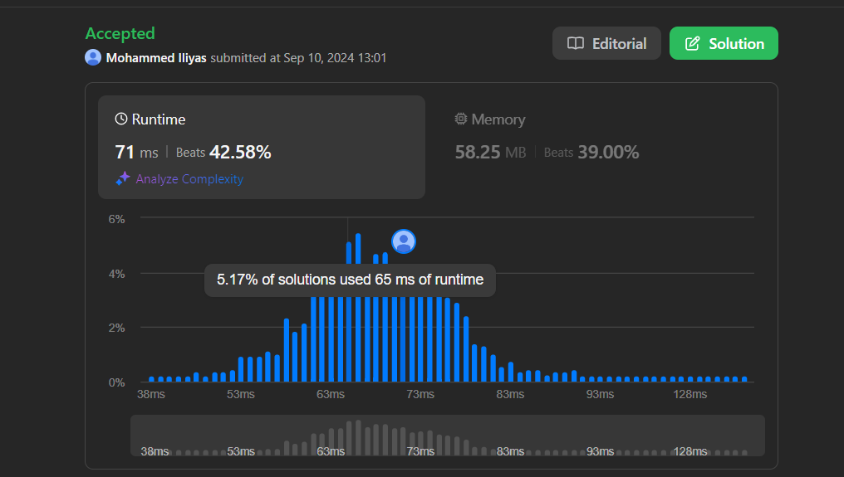

Time Complexity-O(n)

Space Complexity-O(n)

1. Question: <https://leetcode.com/problems/trapping-rain-water/description/>

Solution: <https://leetcode.com/problems/trapping-rain-water/post-solution/?submissionId=1385127957>



Time Complexity-O(n)

Space Complexity-O(n)